ALEXA SKILL SET :

1. To create the Alexa skill set we need to have an account in amazon Alexa .[click here to create account](https://developer.amazon.com/en-US/alexa/alexa-skills-kit)
2. After creating account create skill . navigate to : products 🡪alexa skill kit 🡪console .
3. Now in developer console we must create the skill kit. Click on CREATE SKILL to create new one .

1. We must give the invocation name. This is used as a wake word for our skill. like hi, Alexa open CANADA REVENUE AGENCY. CANADA REVENUE AGENCY will be wake or invocation name.

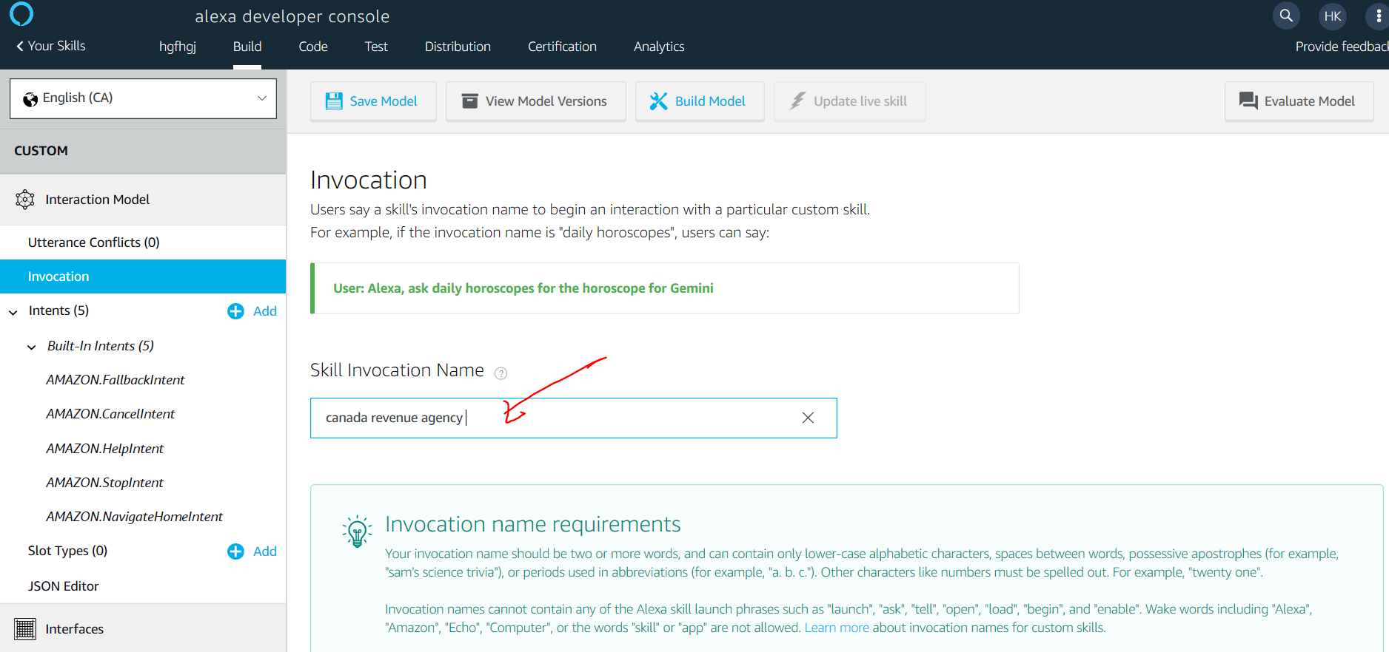

1. Now create intents : we can create custom intents or use the intents from lex also by just uploading the JSON file from the lex console (another amazon web service).

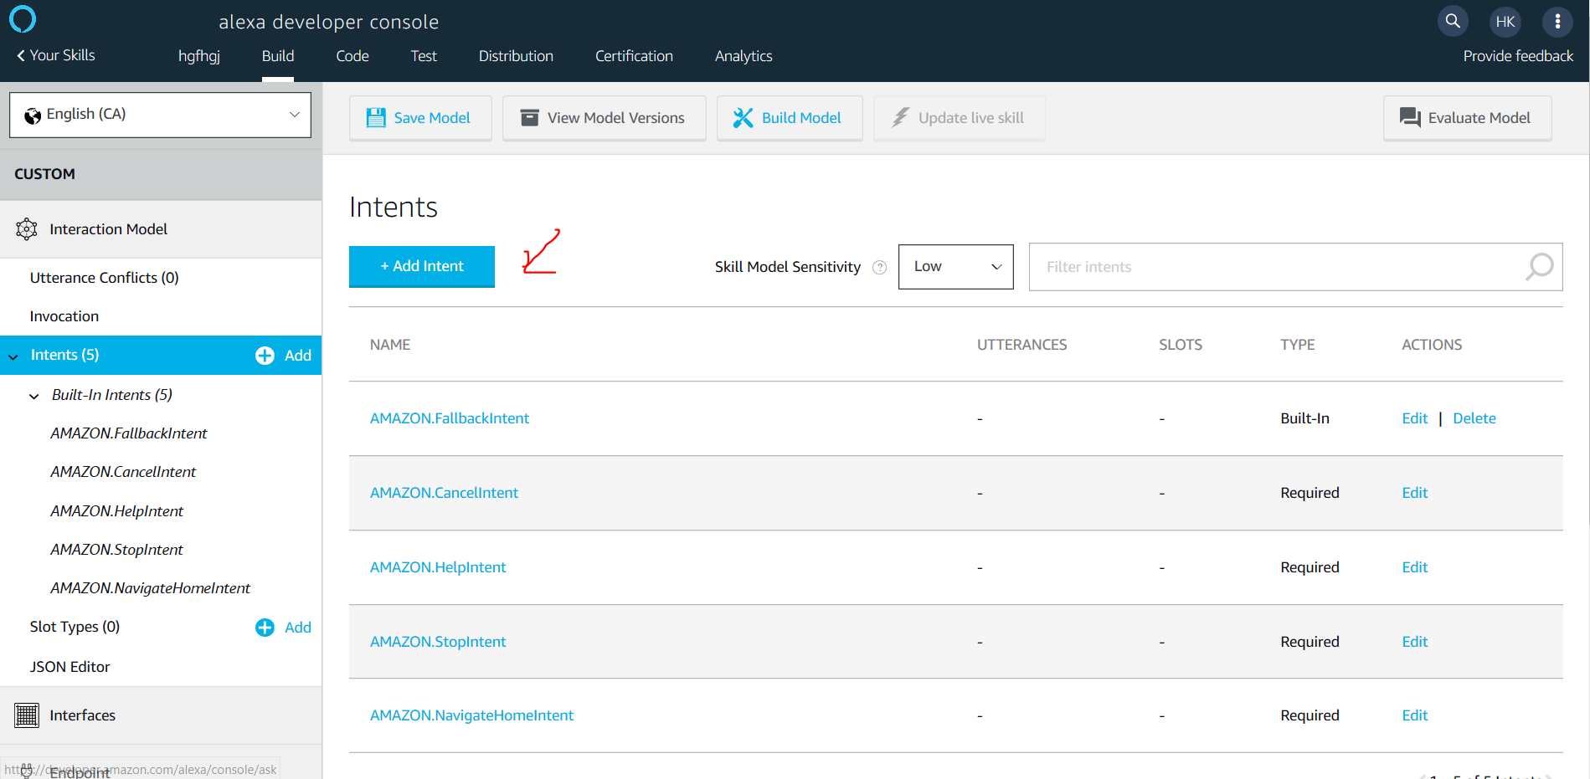

* + - **Create a custom intent : dueDateForMyBalance**

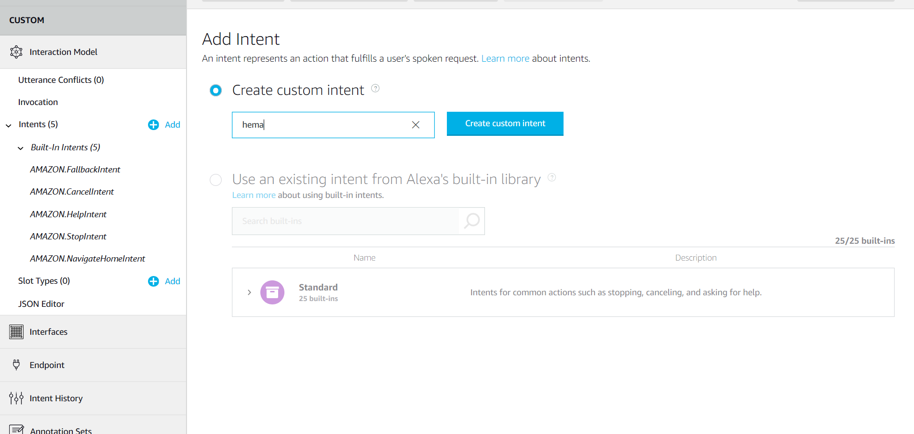

* + - **Create the sample utterances**: these are different ways a user could ask what information he want after he invokes the skill through speech to the alexa enabled device.

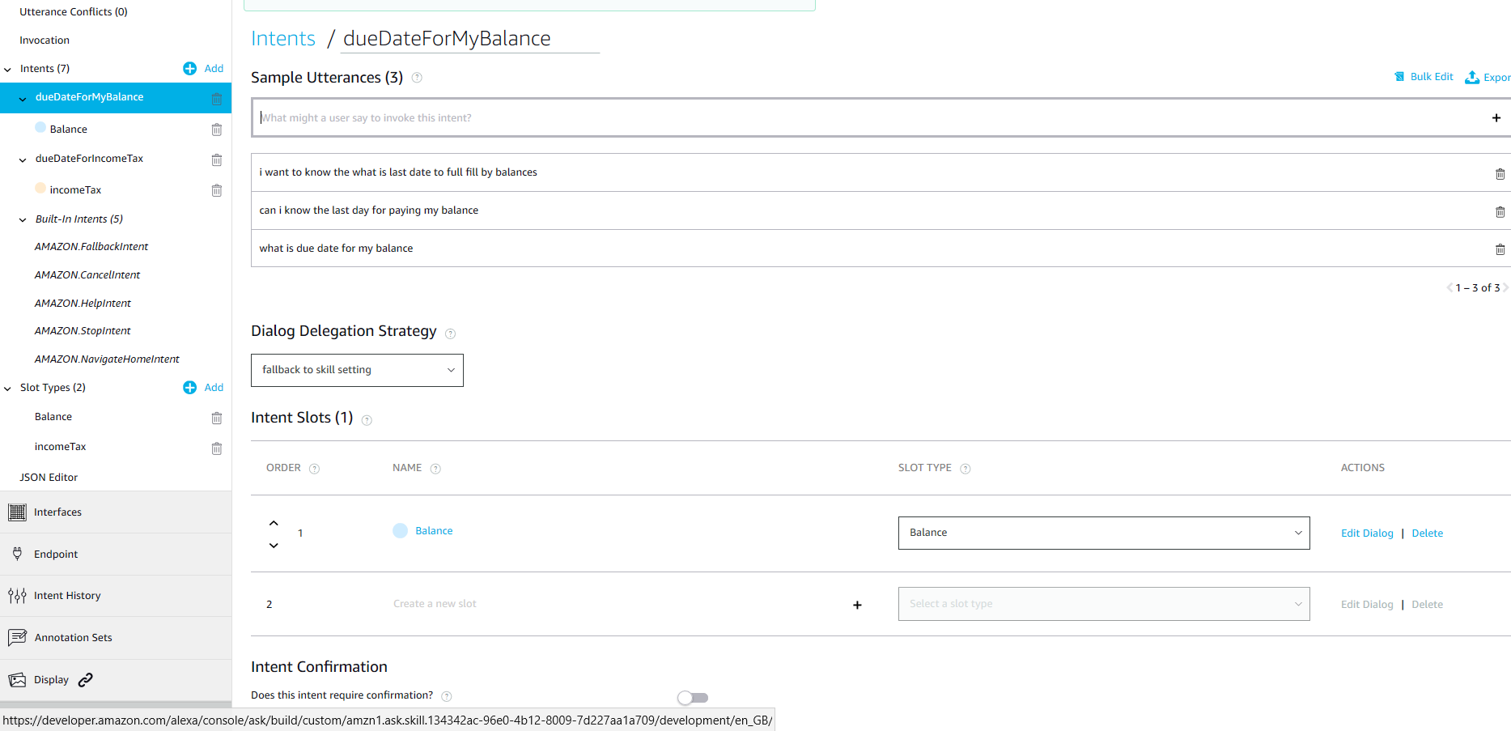

* + - **Slot** are used to store the user data during the talk like when they mention what type of tax –user prompts as income tax. This value is stored till the skill is invoked or this can be stored permanently by sending to data base.

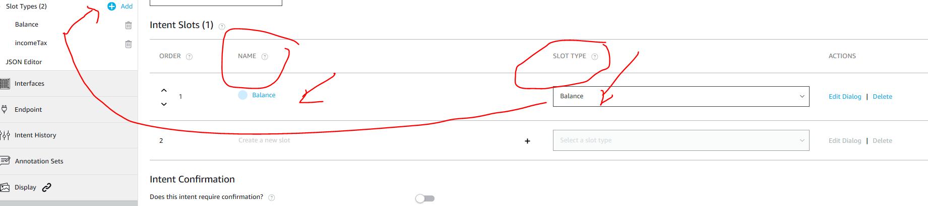

Slot name are the variable names, slot type can be predefined or can be created by using **ADD** on left hand side of screen shot**. Follow below procedure to create the custom slot type.**

* **Process to create the slot type.**

**Step 1:** create new slot type with name

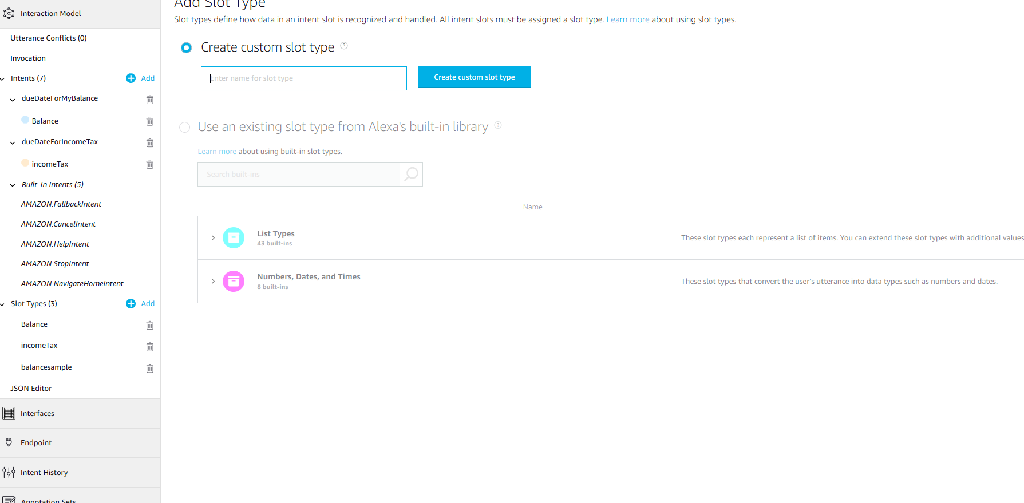

**Step 2:** slot values are the list of values which can be prompted to user / user can select these values.Even we can add synonyms. **See below for the slot type: balance**

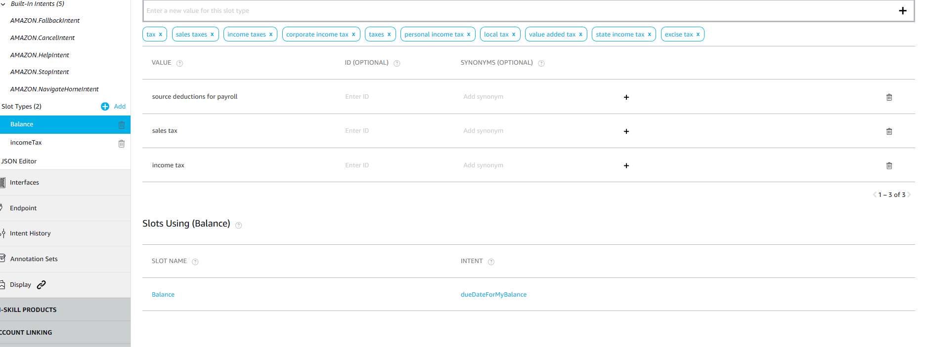

***Now we have successfully created the slot type. this slot type can be used to create slot variables.Once required slots and intents are created we can now goto code .***

1. Go to **code tab** and here we can maintain code which define the functionality of the skill set .

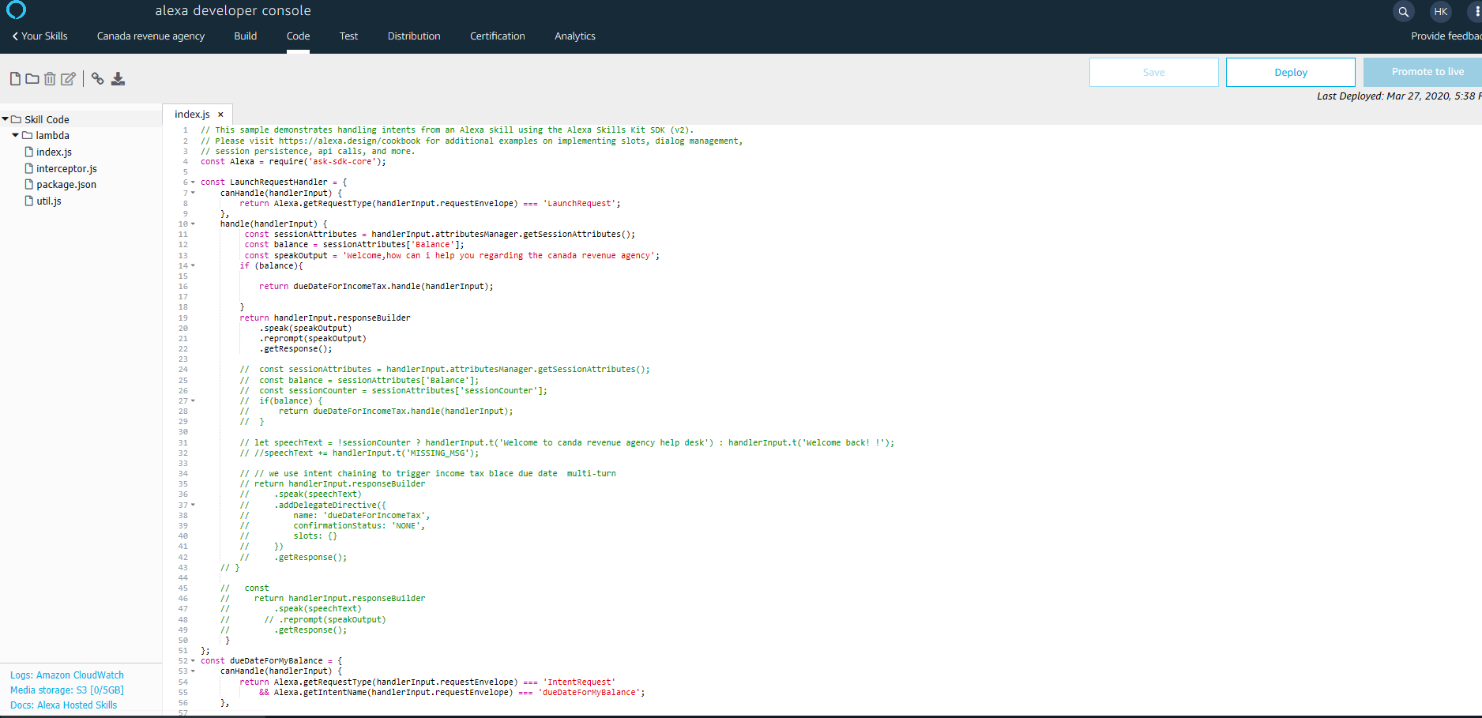

1. Now we have to train the model by clicking on build model in build tab.

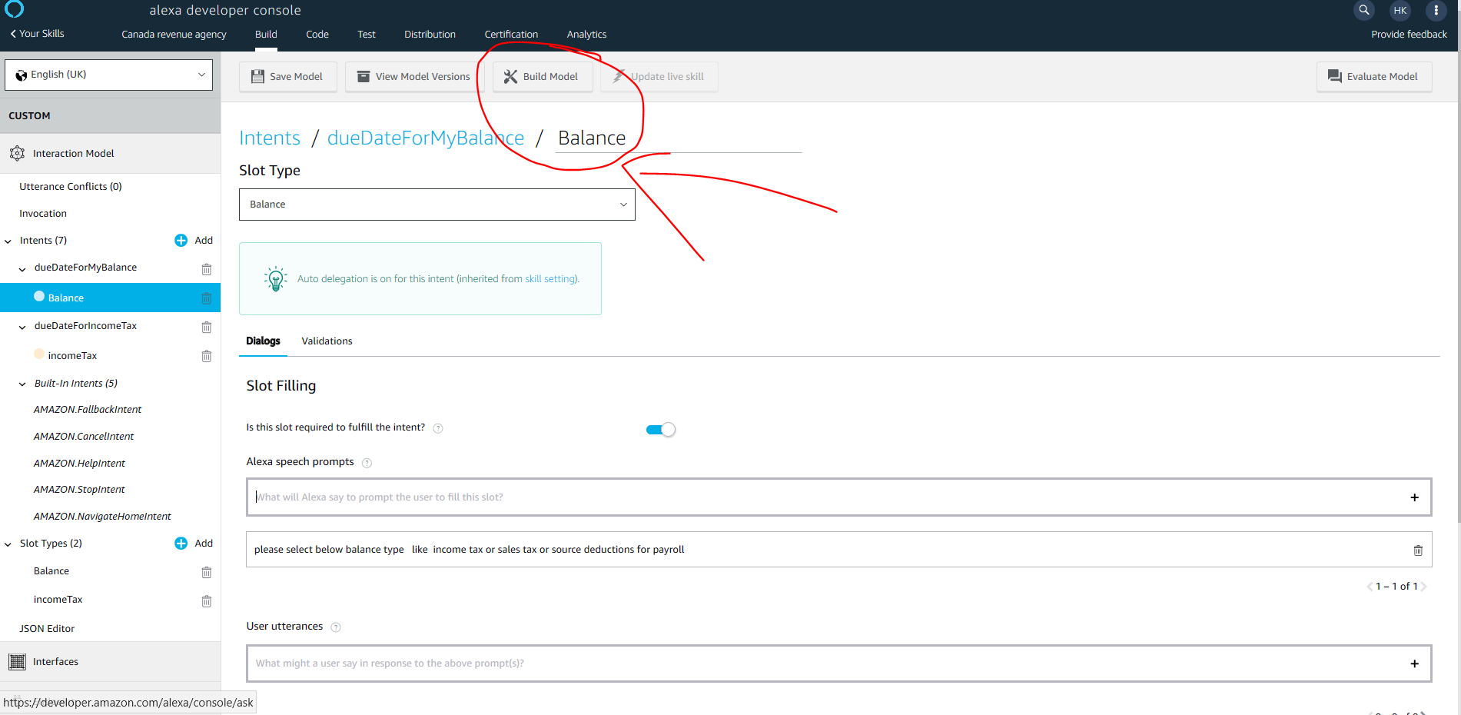

1. Once the model is build we can test it in test tab .

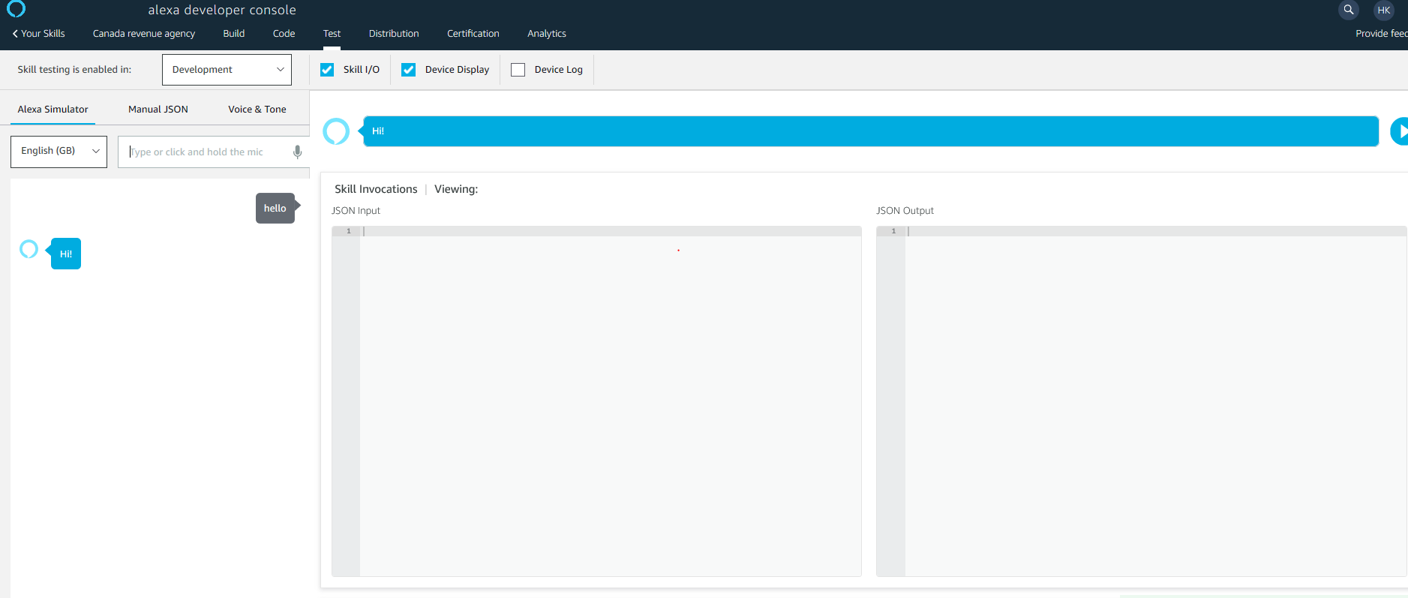

1. Now in distribution tab fill al the below information and click on **save and continue.**

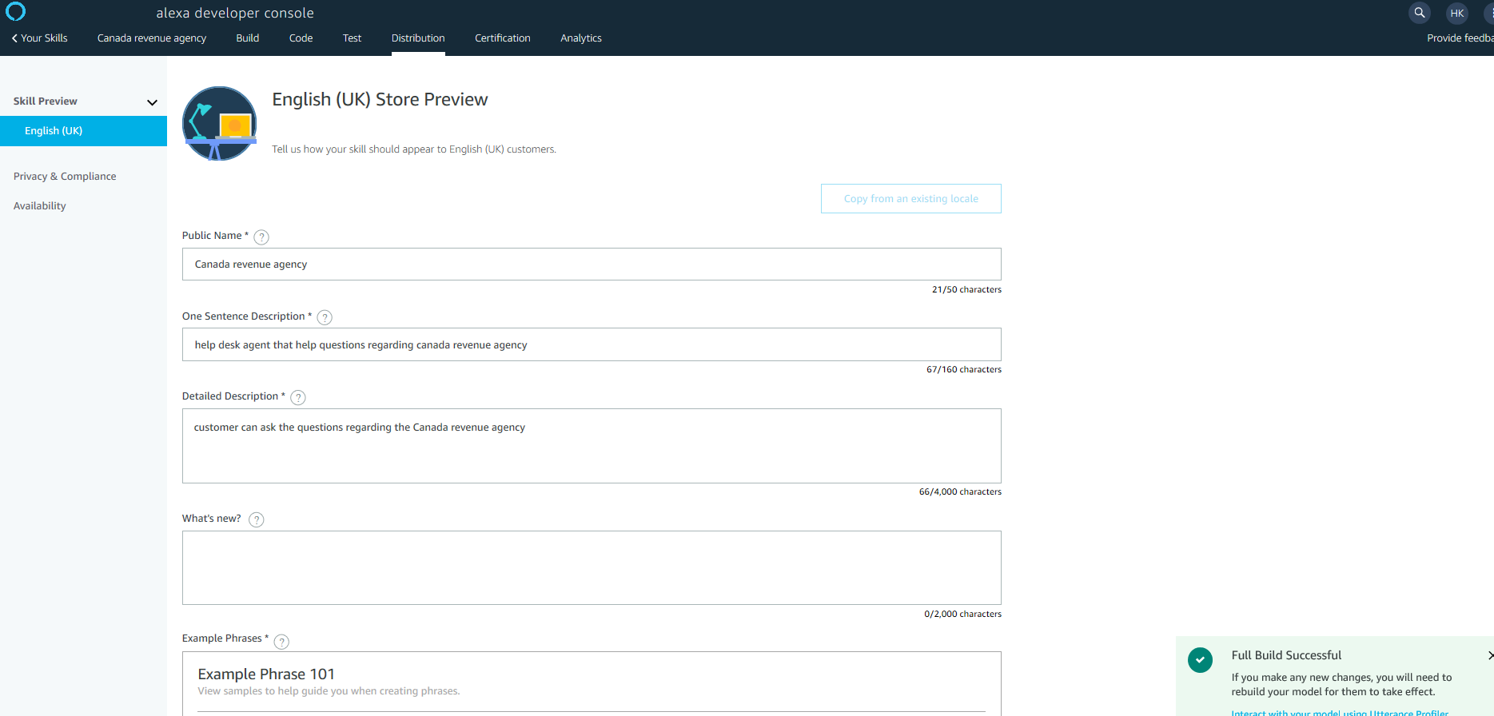

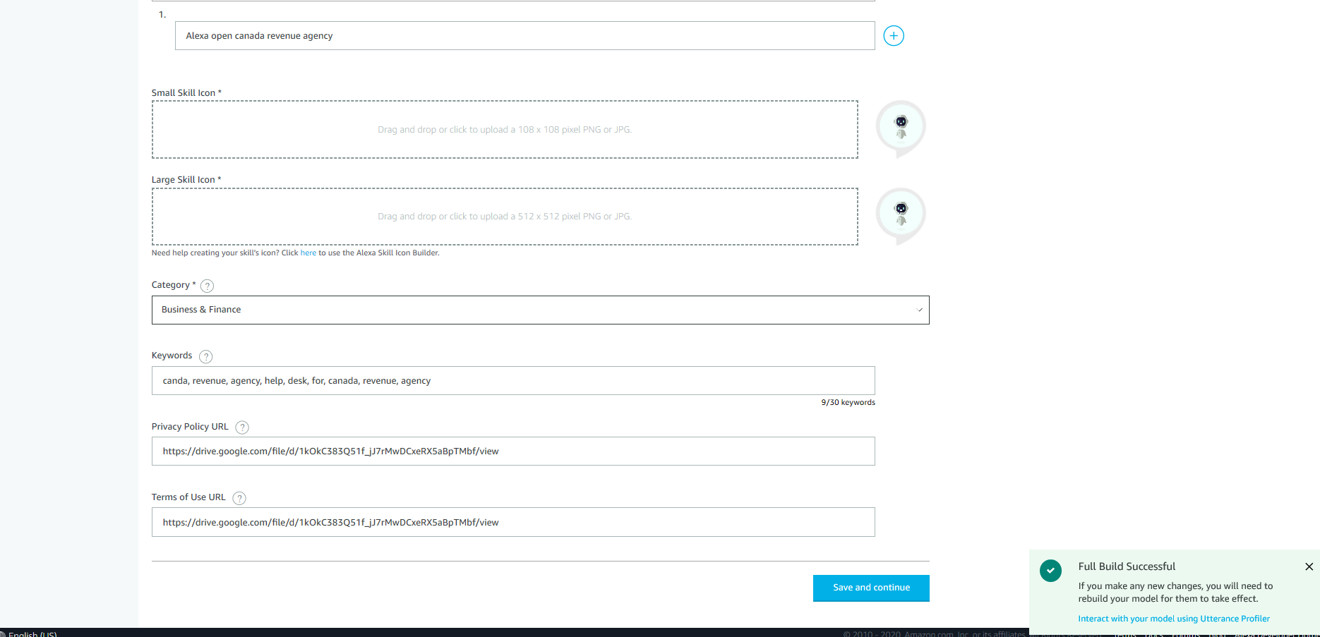

In **privacy and compliance** fill the below details .

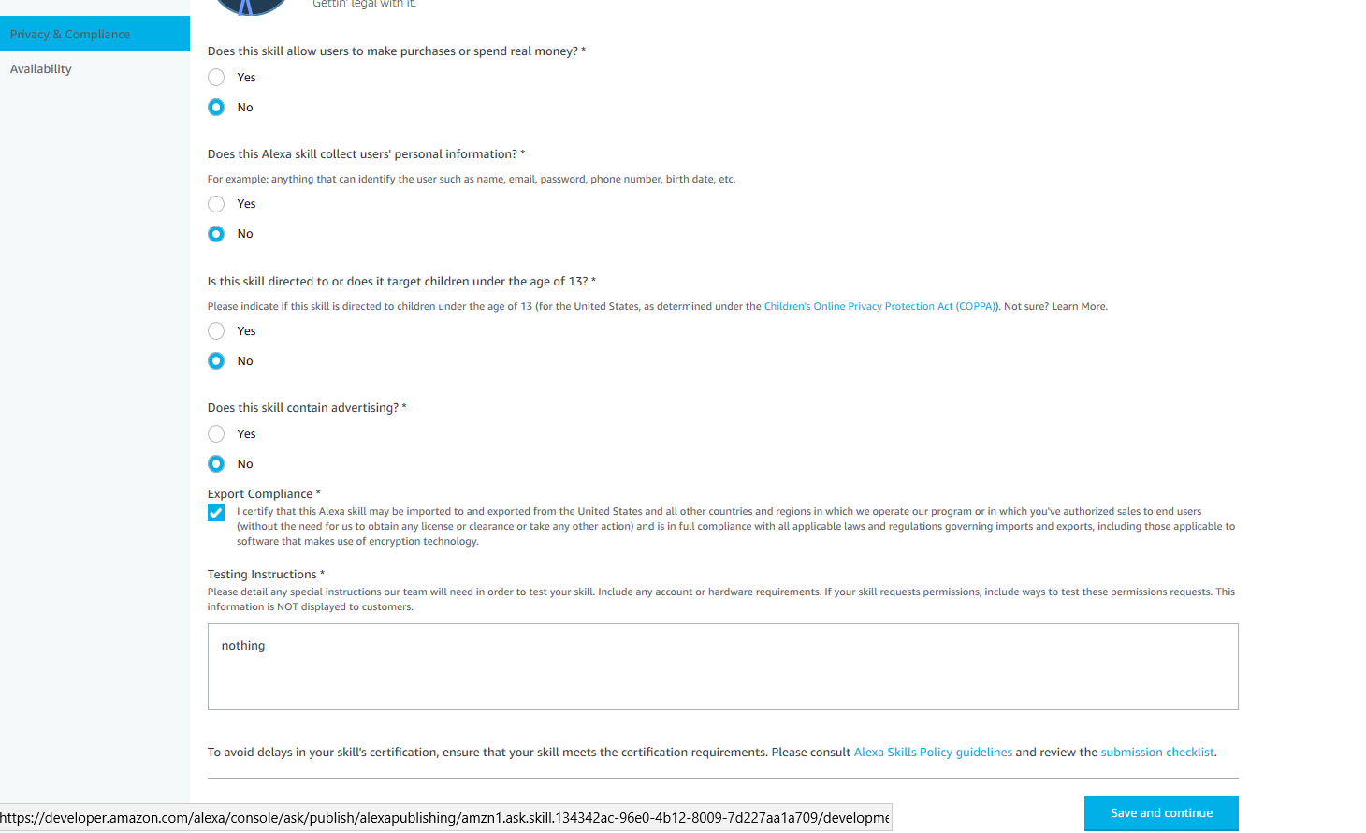

In **availability** fill the below options.

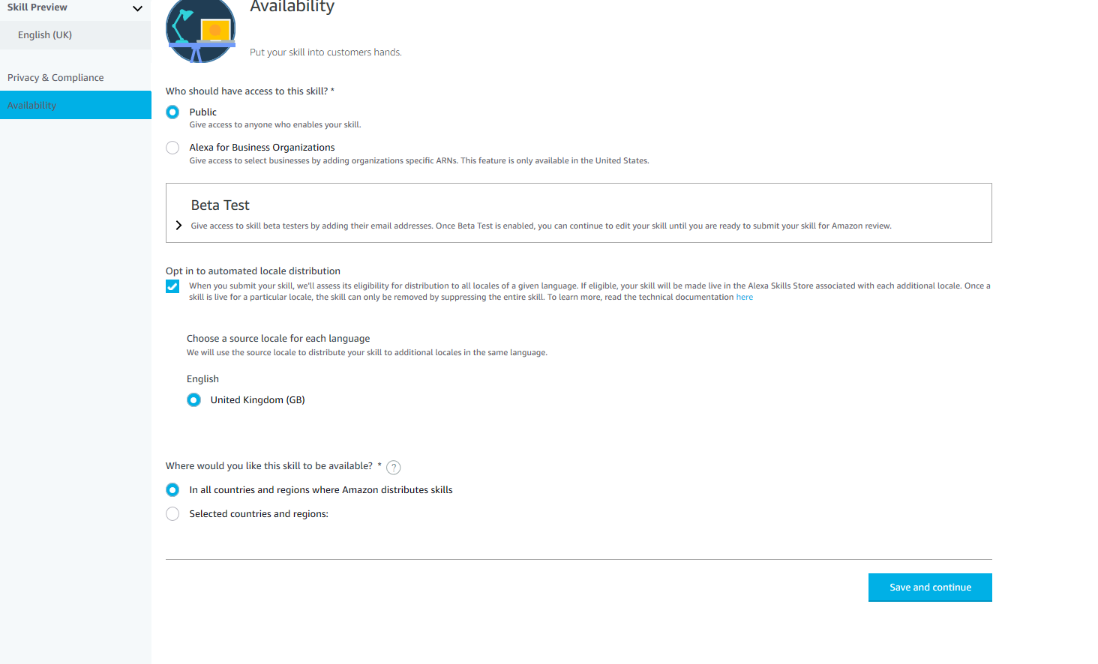

1. In certification tab we have to validate by clicking run and check if it has any error .once everything works fine we wee have below screen .

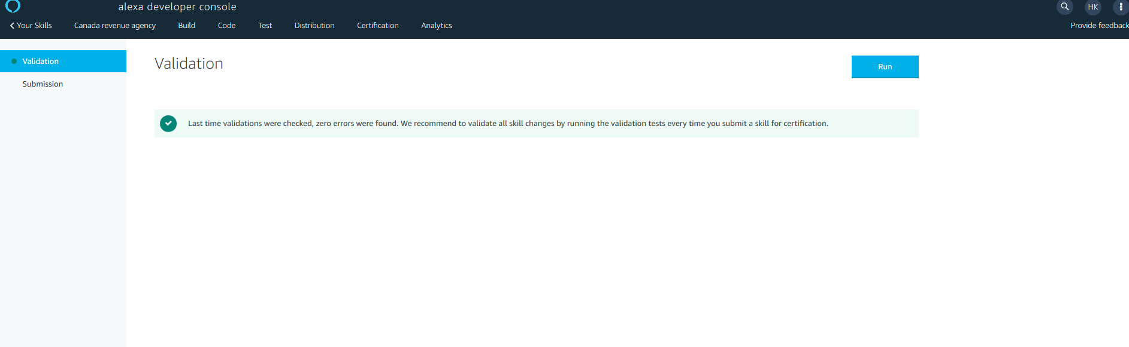

1. After validation we have to submit the skill for review to facebook .Once its accepted by facebook we could use our skill live.

